CALL FOR SUBMISSIONS:
Community engagement for inclusive rural transformation and gender equality
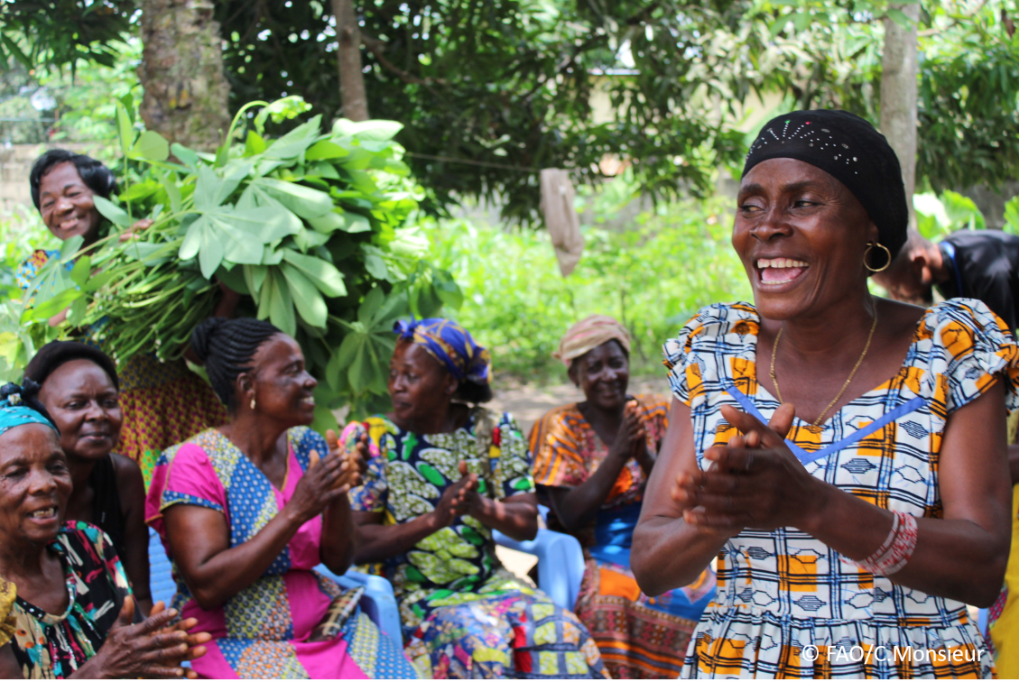
The objective of this call for submissions is to collect good practices, experiences, and lessons learnt on the use of community engagement for inclusive rural transformation and gender equality. The initiative, organized by the Rural Transformation and Gender Equality Division (ESP), seeks to gather insights from a diverse range of contributors, both within FAO and from external stakeholders. Its goal is to share knowledge, foster learning, and guide the scaling up of community engagement and community-led collective action to leave no one behind. The call builds on FAO's past efforts in this area, such as the Community Engagement Days series of webinars.
The call for submissions is open until 13 December 2024.

How to take part in this call for submissions:
To take part in this Call for submissions, please register to the FSN Forum, if you are not yet a member, or “sign in” to your account. Please review the topic note to understand the criteria we are considering for this call. If you wish to learn more about community engagement, you may refer to the background document. Once you have completed this submission template, upload it in the box “Post your contribution” on the call webpage, or, alternatively, send it to fsn-moderator@fao.org.
Please keep the length of submissions limited to 1,500 words and feel also free to attach relevant supporting materials.

Template for submissions

Contact person | Name: Babita Bohra  Organization/Unit: CIFOR-ICRAF  Country: India  Email address: b.bohra@cifor-icraf.org
Name/title of the good practice | Gender Barrier Opportunity Mapping Tool
Where is the good practice taking place? (Multiple selection allowed) | ☐ Europe and Central Asia  ☐ Latin America and the Caribbean  ☐ North Africa and Near East  ☐ Sub-Saharan Africa  ☒ Asia and the Pacific  ☐ North America  ☐ Global
Affiliation | ☒ Farmer and producer organizations  ☐ Trade Union  ☒ Informal community-based, farmer-based or self-help group  ☒ Research and academia  ☐ Government  ☐ Local/traditional authorities  ☐ Private Sector  ☐ Civil Society Organization  ☒ Intergovernmental Organization (e.g. UN system, World Bank)  ☐ Resource Partner/Donor  ☐ Other (please specify)
In which sector(s) and context (s) have you used this community engagement good practice? (Multiple selections allowed) | ☐ Education  ☐ Health and Sanitation  ☒ Food production in agrifood systems (please also tick the sub-categories)  ☐ Crop cultivation  ☐ Fisheries and aquaculture production  ☐ Livestock  ☐ Forestry  ☒ Agroforestry  ☐ Horticulture  ☐ Apiculture (beekeeping)  ☐ Agroecology and sustainable farming practices  ☐ Soil and water management  ☐ Other: ____________  ☐ Post-production in agrifood systems (please also tick the sub-categories)  ☐ Processing and value addition  ☐ Marketing and retailing  ☐ Transporting  ☐ Food loss and waste  ☐ Packaging  ☐ Storage  ☐ Distribution  ☐ Other _________  ☒ Gender Equality  ☐ Climate Action  ☐ Citizenship and Governance  ☐ Social Protection  ☐ Humanitarian and protracted crisis  ☐ Conflict resolution, peace and resilience  ☐ Digital innovation  ☐ Other sector (please specify) _________
Who are the financial partners supporting this good practice, if applicable? | TOFI (Trees outside forests in India) is a joint initiative of USAID and MoEFCC govt of india, Led by CIFOR-ICRAF implemented through five consortium partners in seven states of India (https://www.cifor-icraf.org/tofi/ )
- In a few sentences, summarize your community engagement good practice:

Men and women play distinct roles in forestry and agroforestry sectors, influenced by socio-cultural, economic, and institutional factors. Recognizing these differences, the Barrier, and Opportunity Mapping Tool exercise under the Trees Outside Forests in India (TOFI) program was designed to identify and assess the socio-economic and cultural factors that affect the integration of Gender Equality and Social Inclusion (GESI). This participatory approach engaged community members through training/workshop programs, encouraging them to share their lived experiences, challenges, and potential solutions.
By fostering an inclusive and collaborative environment, this exercise empowered participants to take ownership of the process, deepening their understanding of GESI issues and strengthening community bonds. The insights gained from these discussions provide valuable data on local barriers and opportunities, enabling the development of targeted strategies that address gender inequalities while leveraging opportunities to promote sustainable TOF/agroforestry practices effectively and providing equal opportunities to all.
- What problem(s) or challenge(s) does your good practice aim to address through community engagement?
To effectively address interconnected challenges, we engage communities to tackle socio-economic inequalities, limited participation of women and marginalized groups in decision-making, and barriers to adopting sustainable TOF/ agroforestry practices. By fostering inclusive dialogue, we specifically target gender-specific barriers such as unequal access to resources, cultural norms that restrict women’s roles, and gaps in financial literacy and market linkages. This community engagement approach ensures that solutions are locally relevant and empowers participants to co-create strategies that promote equitable resource management, enhance livelihoods, and strengthen social cohesion. Through this collaborative process, we aim to build a more inclusive environment that supports sustainable development for all community members.
- Describe your good practice in more detail. Include the main guiding principles, the desired changes or outcomes you aim to achieve (Theory of Change), and the key phases of implementation.
Integrating Gender Equality and Social Inclusion (GESI) principles into the implementation of TOF/ agroforestry practices under the Trees Outside Forests in India (TOFI) program. This participatory approach ensures that local communities, particularly women and marginalized groups, are actively involved in identifying challenges and co-developing solutions. The practice was based on USAID’s guiding principles for implementing gender activities like integrated, intersectional, transformative, locally led, accountable, collaborative and do no harm.
Theory of Change
Our engagement is driven by the belief that addressing socio-economic and cultural barriers while leveraging local opportunities can lead to transformational change in GESI outcomes. The desired outcomes include:
- Increased Awareness: Local communities and other stakeholders develop a deeper understanding of GESI issues and their role in promoting sustainable TOF/ agroforestry practices.
- Empowered Stakeholders: Women and marginalized groups feel confident to advocate for their needs and contribute meaningfully to decision-making processes.
- Tailored Solutions: Collaborative, context-specific strategies emerge to address barriers and capitalize on opportunities, driving equitable and sustainable outcomes.

Key Phases of Implementation
· Preparation:
- Conduct initial consultations with state teams to introduce objectives and gather insights.
- Develop a Barrier and Opportunities Assessment Tool to identify GESI-related challenges.
· Facilitation of Workshops:
- Engage community members through participatory workshops to identify barriers and opportunities for GESI integration.
- Use visual mapping exercises for clarity and shared understanding.
· Drafting and Refinement:
- Create and review GESI plan templates with state teams, refining them for local customization.
· Community Validation and Feedback:
- Share findings with community stakeholders to validate insights and reinforce ownership through additional input.
· Co-Creation of Strategies:
- Collaborate with local leaders and community members to design actionable, context-specific strategies.
· Implementation and Monitoring:
- Implement co-developed strategies with consistent support, including capacity building and market linkages.
- Monitor and evaluate progress to ensure continuous improvement.
- Who are the key actors and stakeholders involved in the design and implementation of the good practice, and what are their respective roles? Consider local partners, government, local authorities, community radios, civil society, research, the private sector, etc.
Local communities (farmers), government agencies, local authorities, Gender Advisory Groups (GAGs) specially formed for TOFI (comprising two members from each state), state universities like Assam Agricultural University (AAU), CIFOR-ICRAF-TOFI, research institutions, Self-Help Groups (SHGs), Farmer Producer Organizations (FPOs), Farmer Producer Companies (FSCs), Krishi Vigyan Kendra's (KVKs), private sector entities, NGOs, and INGOs played pivotal roles in the initiative. Their responsibilities included providing feedback and suggestions, facilitating networking, supporting implementation, and serving as resource persons for specific training programs across the seven TOFI states. This collaborative framework ensured the integration of diverse expertise and perspectives into the program's success.
- How does your intervention ensure inclusivity and equal and meaningful participation within the community?
Describe how your intervention includes and engages different groups within the community. Consider aspects like gender, age, ethnicity, disability status, livelihoods, and other specific conditions (e.g., people living in prolonged crisis, migrants, refugees). Explain how your intervention engages diverse segments of the rural community. Highlight the specific actions or strategies you use to reach these groups. If applicable, mention if your intervention uses specific approaches such as gender-responsive, gender-transformative, intersectionality, or other methods to ensure inclusivity and gender equality.
Our intervention is designed to promote inclusivity and meaningful participation by engaging diverse groups within the rural community, with particular attention to gender, age, ethnicity, disability status, and livelihoods. By employing gender-responsive and intersectional approaches, we ensure that all voices are heard, barriers to participation are addressed, and solutions are tailored to the specific needs of each group.
Engagement of Women and Marginalized Groups, Addressing Structural Barriers, Intersectional Lens, Diverse Stakeholder Engagement, Community-Led Participation, Targeted Outreach, Capacity Building and Empowerment and Monitoring and Evaluation: all these strategies by engaging women and marginalized groups, addressing structural barriers, and applying an intersectional lens, the approach ensures that diverse needs and challenges are acknowledged and addressed. Diverse stakeholder engagement and community-led participation empower local voices, ensuring ownership and sustainability. Targeted outreach ensures that underrepresented groups are actively included, while capacity building and empowerment equip individuals and communities with the skills and confidence to drive change. Monitoring and evaluation provide a framework for assessing progress, identifying gaps, and adapting strategies to enhance impact. Together, these strategies create a holistic and transformative approach to achieving sustainable development outcomes.
- By using community engagement, what results and impacts have your good practice achieved?
Please provide specific examples and evidence demonstrating the effectiveness of your intervention, focusing on both qualitative and quantitative outcomes related to livelihoods and well-being improvements.

Using the Gender Barrier and Opportunity Mapping tools, we have identified key barriers in integrating GESI in TOF/ agroforestry practices, as well as the specific needs of local communities based on their geographic context and available resources. Simultaneously, we have pinpointed opportunities to address these challenges through targeted interventions. Within the TOFI program, each component is designed to create opportunities for women, marginalized groups, and individuals with disabilities, ensuring inclusive and equitable development across all initiatives.
- Among these results, has the good practice led to improvements in terms of gender equality, women’s empowerment, and/or social inclusion?
Describe the behavioral changes in terms of gender that the good practice promotes, emphasizing agency, leadership, and participation in local governance. Include efforts to challenge discriminatory norms and unequal power dynamics. Highlight also how the intervention has supported the well-being (including psychological resilience) of marginalized groups and enhanced their inclusion and participation in decision-making processes.
Yes, it is evident that our teams and stakeholders are highly committed and attentive to integrating the GESI component into the TOFI program.
- What key challenges did you encounter while implementing the community engagement activities, and how did you address them?
Include any resistance from communities, pushback, or issues related to unequal power dynamics, if applicable.
Yes, during the TOFI master training programs, we noticed lower participation from women when the sessions were held at district centers. Many community members expressed concerns about household responsibilities, which prevented women from attending. To address this, we shifted the training sessions closer to the villages or held them at community centers, significantly increasing women’s participation—in some states, their participation even exceeded that of men. This highlights the importance of making resources and opportunities accessible to everyone.
Additionally, we identified gaps in women’s ability to use digital technology and access the internet, emphasizing the need for tailored, need-based training. In response, we are actively working on skill-based training programs tailored to the specific needs of each state, ensuring women and marginalized groups gain the tools they need to fully participate and benefit from these initiatives.
- What are the key lesson learned from your community engagement good practice?
We need to prioritize upgrading the skills of local communities by focusing on need-based training programs that address their specific challenges and opportunities. Equally important is sensitizing local communities to create awareness and foster a sense of ownership in development initiatives. The goal is to empower communities to become self-sufficient and achieve long-term sustainability, reducing their reliance on external programs. Additionally, connecting them with economic return-based activities will enable them to generate stable incomes and enhance their livelihoods independently.
- Has this practice been replicated in the same context or in different contexts?
What are the required conditions to replicate and adapt the practice in another context/geographical area? This tool we can apply globally.
Yes, this practice has been successfully replicated in both similar and different contexts, demonstrating its adaptability to diverse socio-economic and cultural conditions. To replicate and adapt the practice in a new geographical area, it is essential to conduct a thorough analysis of the local context, engage stakeholders such as governments, NGOs, and community leaders, and ensure active participation and ownership by the community. Tailored capacity-building programs must align with the community's specific needs, with a focus on empowering marginalized groups such as women and people with disabilities. Adequate resources, supportive policies, and robust monitoring mechanisms are critical to ensuring the practice’s effectiveness and sustainability. Flexibility in design and implementation, coupled with ongoing community feedback, allows the approach to be refined and adapted to address unique local challenges effectively.
- How sustainable are the results achieved by this good practice?
Describe the key elements that need to be in place to make the initiative sustainable, including enabling environment (legal and policy frameworks and institutions), local ownership, accountability, etc.
The results achieved are designed to be sustainable through local ownership, supportive policies, and economic viability. The participatory approach ensures communities are actively involved in decision-making, fostering a strong sense of responsibility and long-term commitment. Aligning the initiative with legal and policy frameworks and securing institutional support from local governments and organizations further reinforces sustainability. Economic viability is enhanced by linking activities to income-generating opportunities, such as market access for agroforestry products, while capacity-building programs equip communities with the skills needed to maintain and scale the initiative independently. Additionally, transparent accountability mechanisms and adaptive management practices ensure ongoing relevance, responsiveness, and resilience in the face of changing conditions, making the results both impactful and enduring.
- Based on the conversations FAO held during the Community Engagement days, a definition of community engagement for empowerment was proposed:

“Ccommunity engagement for empowerment and community-led collective action can be defined as an inclusive and participatory process that enables community members to become active agents of change in decisions affecting their lives, health, and environment. This process develops their capacity to achieve sustainable outcomes for improved rural livelihoods. Embracing a rights-based approach, it prioritizes the agency and participation of all community members, regardless of gender identity, sexual orientation, age, ethnicity, caste, socioeconomic status, political affiliation, migration status, or ability/disability. Indeed, inclusive approaches recognize the complexities of overlapping marginalization and discrimination that can exclude different community members from decision-making processes and implement strategies to foster their participation, agency and empowerment.”

We invite you to contribute to this definition. What would you add or change? Please share your thoughts, suggestions, and any additional elements you believe are crucial for a comprehensive understanding of community engagement approaches aimed at community-led collective action for inclusive rural transformation, people’s empowerment and gender equality.

We should also consider perspectives of accountability, partnerships, and long-term sustainability, emphasizing the significance of adaptability, community ownership, and transformative change as core elements of effective community engagement.
- Based on your experience, what gaps or areas for improvement still need to be addressed in the field of community engagement?
Limited Inclusion of Marginalized Groups: Despite efforts, certain groups such as women, ethnic minorities, people with disabilities, and migrants often remain underrepresented in community engagement initiatives. More targeted and culturally sensitive approaches are needed to ensure their active participation. Especially when the trainings programs are outside their villages, this we have experienced in TOFI.
Insufficient Capacity Building: Community members often lack the skills and resources to fully participate in decision-making or implementation processes. Providing tailored training and support can empower communities to engage more meaningfully.
Weak Feedback Mechanisms: Feedback loops between communities and program implementers are often inadequate, leading to a lack of transparency and diminished community ownership. Structured and consistent mechanisms for gathering and responding to feedback are essential.
Limited Resources and Accessibility:
In rural or resource-poor settings, logistical challenges such as lack of transportation, childcare, or accessible venues hinder participation. Addressing these barriers through better planning and resource allocation is critical.
Monitoring and Evaluation Deficit: There is often a lack of robust monitoring and evaluation systems to measure the impact of community engagement. Collecting disaggregated data and tracking outcomes over time can improve accountability and program effectiveness.
- What do you think is FAO's role in the field of community engagement? How can FAO support and enhance interventions like yours, if applicable? Consider aspects such as policy advocacy, capacity development, funding, technical assistance, knowledge production and sharing, and fostering partnerships.

FAO plays a crucial role in community engagement by advocating inclusive policies, building capacity, and fostering partnerships to empower local communities. It provides technical assistance, funding support, and shares knowledge to enhance participatory approaches and sustainable practices. Additionally, FAO’s data quality and extensive outreach can be invaluable resources for organizations, ensuring interventions are impactful, scalable, and aligned with global development goals.

Link(s) to specific references about your good practice (e.g. reports, communication products, videos, articles)  Gender Barrier and Opportunity Mapping Tool_CIFOR-ICRAF_TOFI.pdf  https://www.cifor-icraf.org/tofi/ | Please include attachment(s) or add here link(s) to documents/videos/podcasts/other with specific references.

The call for submissions is directly aligned with the thematic components of collective action within FAO's Programme Priority Areas (PPAs), specifically Better Life 1 (Gender Equality and Rural Women’s Empowerment), Better Life 2 (Inclusive Rural Transformation) and Better Life 3 (Agriculture and Food Emergencies).

